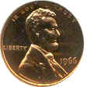
Archaeology of a Coin Name __________________ Period ____
1. What is the date your coin was minted? _________
2. Whose picture is on the heads side of your coin? __________________________
3. Why do you think this person was chosen to be on your coin?
4. List any religious symbols or religious words on your coin.
5. Write down all of the phrases you find on your coin.

6 . What languages are on your coin?
7. Describe the building on your coin?

8. Name the building on your coin.

