LEGAL RESEARCH TEAMS ACTIVITY
Point Value - 100 pts, DUE, WESDAY OCTOBER 30

Case Assigned:
- Case 7 – Ted Bundy
- Case 8 – Michael Peterson
- Case 9 – Casey Anthony
- Case 10 – Jeffrey MacDonald
- Case 11 – The Trial of Amanda Knox
- Case 12 – Scott Peterson

- Case 1 - Adnan Syed: A High School Murder
- Case 2 - O.J. Simpson Murder Trial
- Case 3 - The Case of Steven Avery
- Case 4 - The Jinx: Robert Durst Case
- Case 5 - The Death of JonBenet Ramsey
- Case 6- Amanda Knox

Roles (maximum of 4 people per group):
- Lead Detective - In charge of leading group discussions, presenting information to the class, assigning evidence to be evaluated, and narrowing down conclusions of the group.
- Writer - Responsible for drafting and finalizing main briefing that will be presented to the class.
- Researcher - Gathering credible sources, evaluating evidence, presenting facts/evidence to the group, distributing links/sources to the group.
- Lead Assistant - Can branch off with researchers, in charge of group if detective is absent, responsible for creating suspect chart.

Tasks:
- Research: (25 Points) Independently find 5 sources that related and present information on the case. This can be documentary episodes, podcasts, case files, rulings, and news articles. Two of your sources must be in print from a reputable source. One of your sources must be from the actual case. List these sources on your chart and explain their importance to your case.
  - Formatted correctly
  - Paragraph description of how the sources was used and what info that source provides. Do not expect to receive full credit for this part if you simply write a few sentences per source.

- Suspect Chart (20 Points) (NOT JUST A POSTER!!!) - Create a chart that shows the victim(s), suspects, and people involved. You do not need to use pictures but this does need to appear neat and thorough.
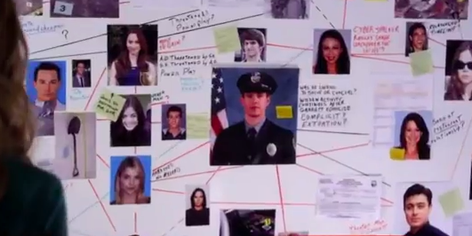

- Presentation: (25 Points) Using Keynote/Google Slides/PowerPoint, etc… MUST include the following:
- Name of the Case
- Year of crime + conviction/closing date
- Why is this such a famous/well known case?
- General path of the case through the criminal justice system + Ruling (Outcome of the Case)
- Major Evidence: Please state if this was used in the case and how it impacted the case. You must also include one piece of missing evidence.
- Research Team Opinion: What is the overall conclusion of your research team? How would each of your group members voted in a jury situation?
- Predictions: Will we here about this case in the future? If so, how?

- Documentary Trailer: (25 Points)
  - 2-4 minutes
  - Provides a narration of the case
  - Professional sounding audio and video
  - Should provide a summary of the case
  - Should leave the viewer questioning the outcome of the case
Checklist

Research (25)
___Formatted correctly (5)
___A full and comprehensive paragraph for each of the 5 sources describing how it was used and its importance (20)
Suspect Chart (25)
___Shows the victim, criminal, and possible suspects of the case (10)
___Uses lines, connections between the individuals (5)
___Thorough with Information (5)
___Visually Appealing (5)
Documentary Trailer (25)
___2-4 minutes (5)
___Narration (5)
___Provides a summary (5)
___Professional looking and sounding (5)
___Entertainment Value (5)
Presentation (25)
___Correctly uses presentation software which is readable/looks good (5)
___Includes required information found above (15)
___Presenters DO NOT read off the slides. Explain the information in a confident manner, the presentation is practiced and done well (5)

Legal Research Project Source Page

Group Members –

Sources

Last, First M. Book. City: Publisher, Year Published. Print.

Paragraph description of source.

James, Henry. The Ambassadors. Rockville: Serenity, 2009. Print.

Paragraph description of source.

Last, First M. Book. City: Publisher, Year Published. Website Title. Web. Day Month Year Accessed.

Paragraph description of source.

James, Henry. The Ambassadors. Rockville: Serenity, 2009. Google books. Web. 16 Mar. 2010
http://books.google.com

Paragraph description of source.

