Group Members ________________________________________________________ Date ________________ Period ____

**Unit 1 (Map Activity)**

**Directions**: Use your map to answer the following questions.

1. What continents reside on the equator?
2. What continents are in both the eastern and western hemispheres?
3. Which two oceans do not reside in both the northern and southern hemispheres?
4. What ocean separates South America and Africa?
5. What is the largest continent in terms of land?
6. Which continent contains both the highest and lowest points in the world?
7. Which continent is not really a continent?
8. Which continent contains the world’s only poisonous lizards?
9. Which continent contains the second largest mountain chain and river?
10. Which continent is the smallest?
11. Which continent contains the world’s longest river and largest desert?
12. On which continent is the Middle East located?
13. Which continent receives on average 50 millimeters of rain a year?
14. Which continent has no official language?
15. Which continent has no deserts?
16. Which two continents are completely surrounded by water?
17. Name one continent that lies in three hemispheres.
18. Name two continents in which the prime meridian passes.
19. Which continent has the largest fresh water lake?

**Latitude and Longitude Practice**

**Part I: Label the map.**

180º W

90º S  
45º N  
0º Latitude  
45º S  
90º E

135º E  
135º W  
90º N  
45º W  
0º Longitude

45º E  
90º W  
180º E

[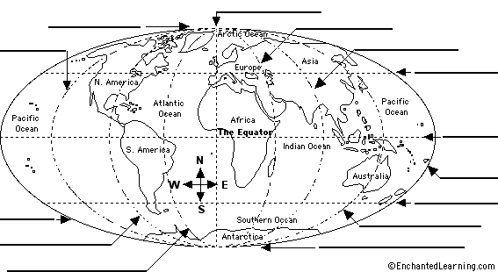](http://www.enchantedlearning.com/label/)

**Part II: Match the longitude or latitude location and description.**

|  |  |  |
| --- | --- | --- |
| 1. | _____ | Passes through the United States and Africa. |
| 2. | _____ | Passes through Africa, the Middle East and Russia. |
| 3. | _____ | Passes through Australia, Africa and South America. |
| 4. | _____ | Passes through India and Africa. |
| 5. | _____ | Passes through Russia and India. |
| 6. | _____ | Passes through Greenland. |
| 7. | _____ | Passes through Alaska the Pacific Ocean. |
| 8. | _____ | Passes through Europe and Africa. |
| 9. | _____ | North Pole. |
| 10. | _____ | Passes through the United States and Canada. |
| 11. | _____ | Passes through the United States and Europe. |
| 12. | _____ | Passes through Australia and some Southeastern countries. |

|  |
| --- |
| 15°N |
| 30°S |
| 150°W |
| 90°W |
| 75°N |
| 150°E |
| 30°N |
| 45°N |
| 45°E |
| 15°E |
| 75°E |
| 90°N |

**Part III: Match the latitude and longitude with location. In the last column state the hemisphere.**

|  |  |  |  |
| --- | --- | --- | --- |
|  | **Latitude/Longitude** | **Place** | **Hemisphere** |
| 1. | 35°N,90°W |  |  |
| 2. | 60°N,120°W |  |  |
| 3. | 90°S,90°W |  |  |
| 4. | 30°S,60°W |  |  |
| 5. | 30°S,120°E |  |  |
| 6. | 15°S,30° E |  |  |

*Pick from these place answers: Canada, Africa, Antarctica, United States, Australia, South America

**Part IV: Read and Answer.** The area bounded by the Tropic of Cancer on the north and Tropic of Capricorn on the south is known as the "tropics." This area does not experience seasons because the sun is always high in the sky. The Tropic of Cancer (north) and the Tropic of Capricorn (south) each lie at 23.5 degrees latitude. List five countries that lie within the tropics.